**Part 1 wind imposed on closed basin without density changes**

1. Performance of K-epsilon model

as in a closed basin, with imposed uniform wind speed on lake, water level in the free surface may swing all the time. basically we see oscillation of water depth along distance.

tab.1 setup1

|  |  |  |  |  |  |
| --- | --- | --- | --- | --- | --- |
|  | Bathymetry | Grid | Windspeed | 3d model | Viscosity |
| Fig1 | Uniform | No extend | 0-1-1 | K-epsilon | 1e-6 |
| Fig2 | Uniform | No extend | 0-1-1 | K-epsilon | 1e-3 |
| Fig3 | Uniform | No extend | 0-1-1 | K-epsilon | 0.1 |
| Fig4 | Uniform | With extend | 0-1-1 | k-epsilon | 1e-6 |
| Fig5 | Shallow | With extend | 0-1-1 | k-epsilon | 1e-6 |

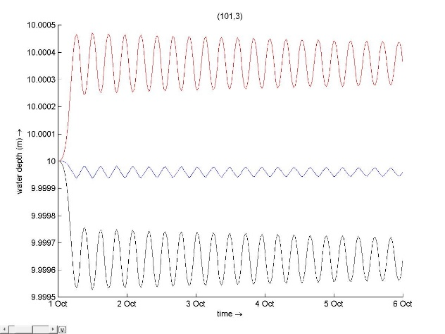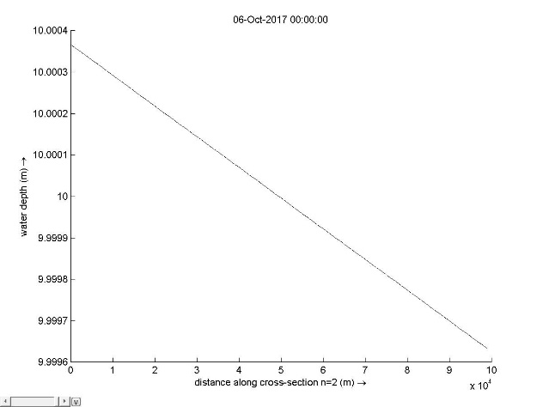

1. (b)

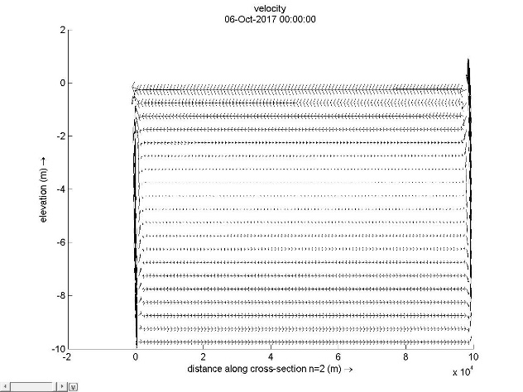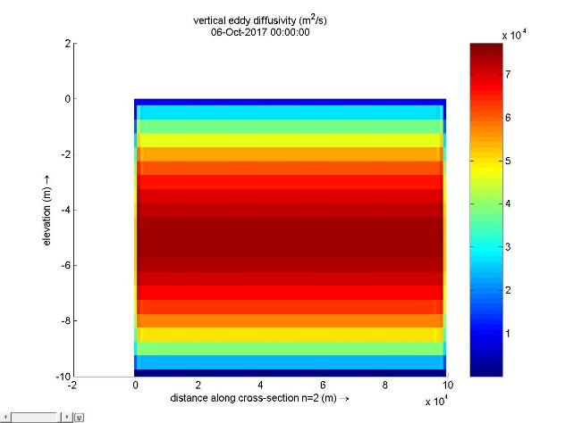

(c) (d)

Fig.1 (a) water depth with time (b) water depth with distance (c) velocity (d) viscosity

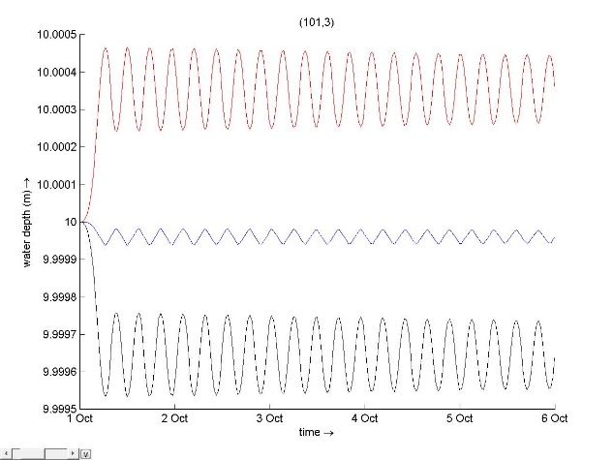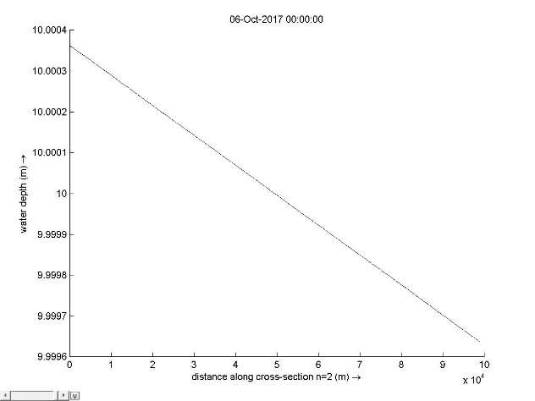

1. (b)

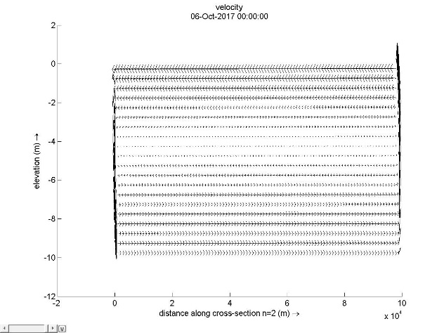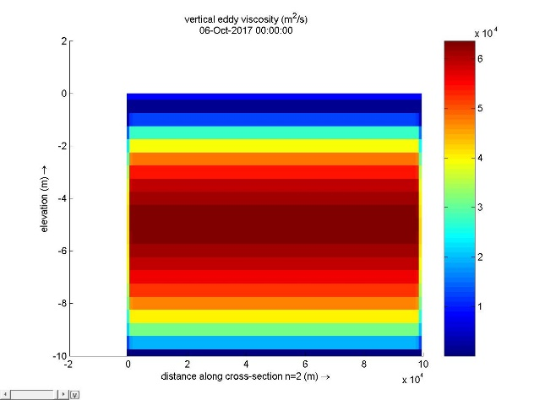

(c) (d)

Fig.2 (a) water depth with time (b) water depth with distance (c) velocity (d) viscosity

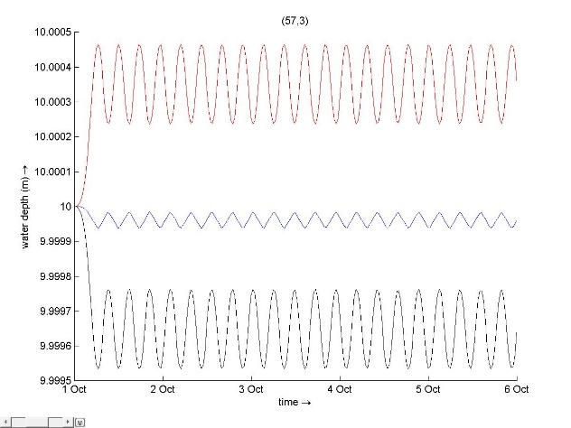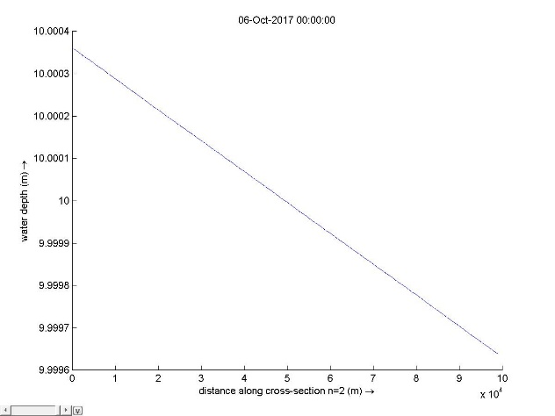

1. (b)

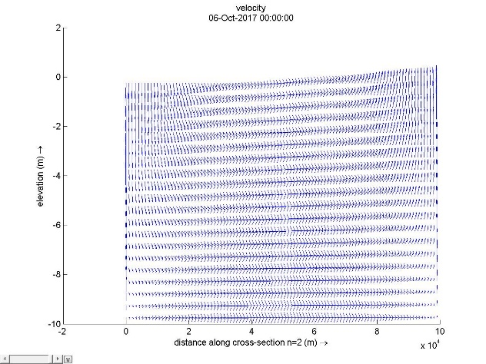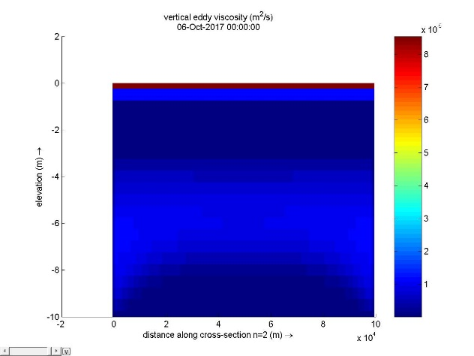

(c) (d)

Fig.3 (a) water depth with time (b) water depth with distance (c) velocity (d) viscosity

Three graphs above show discrepancies with increasing vertical viscosity. Physically, higher viscosity results in higher diffusivity and then quicker mixing. intuitively fig.1 and fig.2 show us well stratification whereas fig.3 with viscosity 0.1 shows us weaken stratification and has already mixed. In this case, the wind speed is quite slow, well stratification is expected.

One issue above is return flow occurs near the edges of the basin. This is mainly due to our assumption of shallow water flow which assumes characteristic horizontal velocity and length are much larger than vertical velocity and length. Actually, codes can not cope with full Naiver-Stokes equation and hence causes artificial circulation.

In order to help code to alleviate such issue, we extend our grids as in fig.4 below.

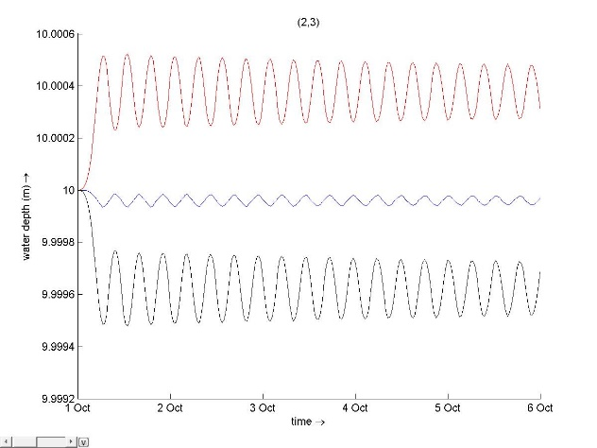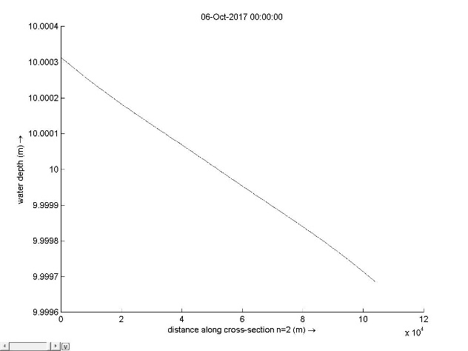

1. (b)

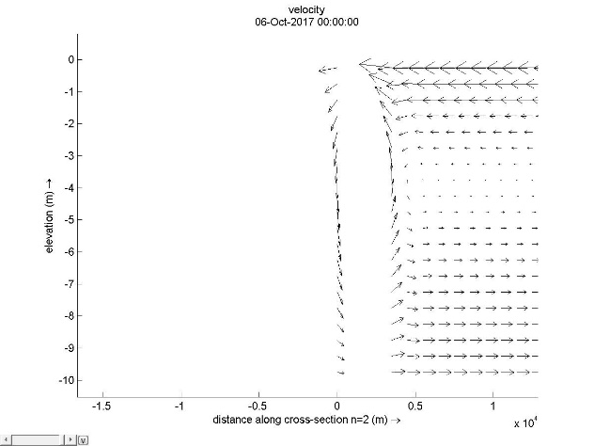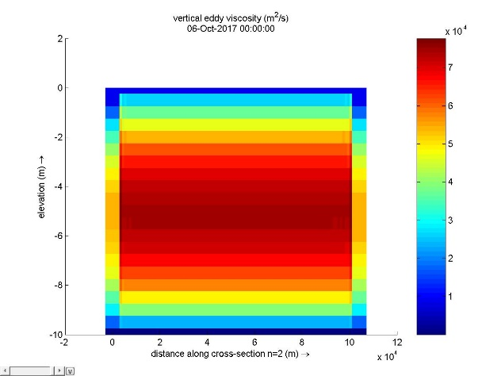

(c) (d)

Fig.4 (a) water depth with time (b) water depth with distance (c) velocity (d) viscosity

In this case, as we extend the grid, area near the edge increases and so vertical velocity becomes smaller. We see stratification becomes clearer in this case.

Backflow issue still lies due to hydrostatic inconsistency. To approach to our real life, we modify bathymetry to create artificial slope as in fig.5.

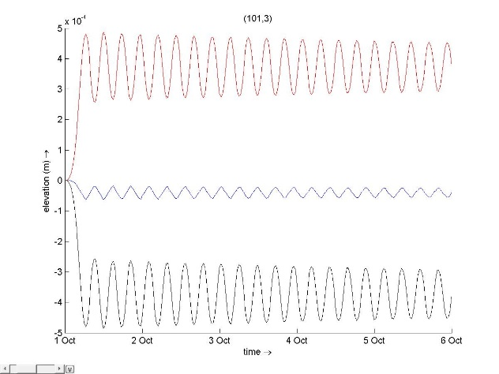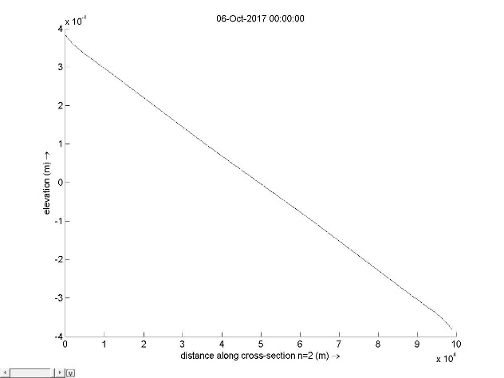

1. (b)

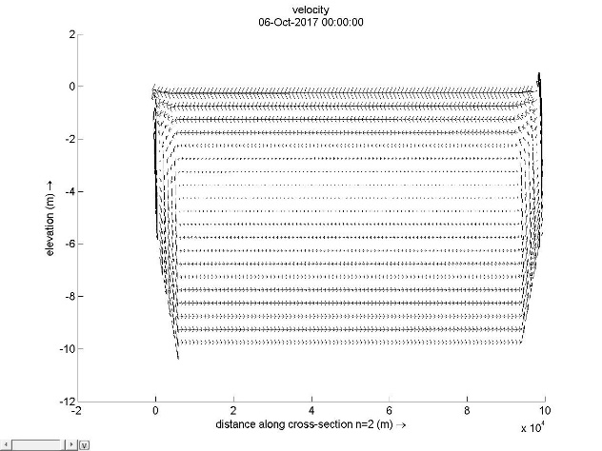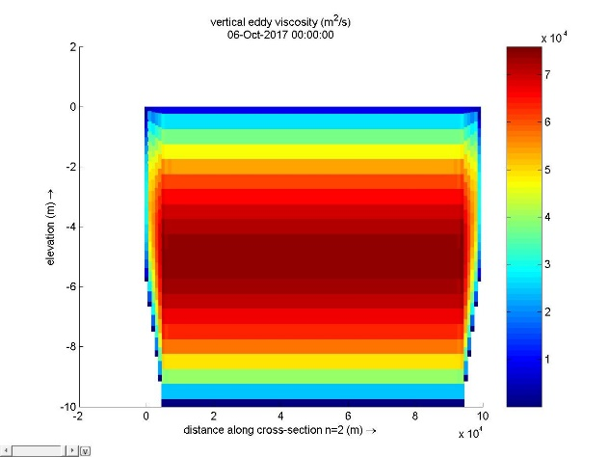

(c) (d)

Fig.5 (a) water depth with time (b) water level with distance (c) velocity (d) viscosity

With given bathymetry, the slope will help to hold hydrostatic consistency. Hence, we notice backflow issue has been alleviated.

1. Performance of K-L model

tab.2 setup2

|  |  |  |  |  |  |
| --- | --- | --- | --- | --- | --- |
|  | Bathymetry | Grid | Windspeed | 3d model | Viscosity |
| Fig.6 | Uniform | No extend | 0-1-1 | K-L | 1e-6 |
| Fig.7 | Uniform | No extend | 0-1-1 | K-L | 1e-3 |

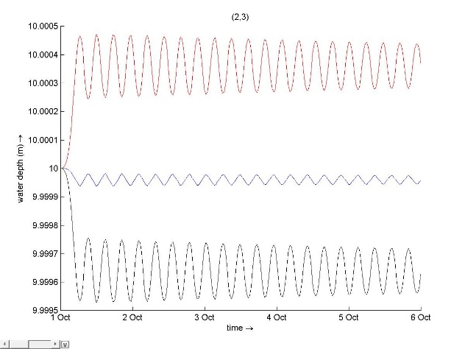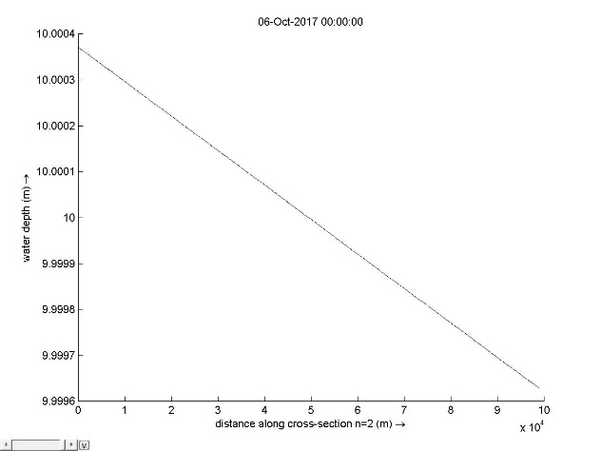

(a) (b)

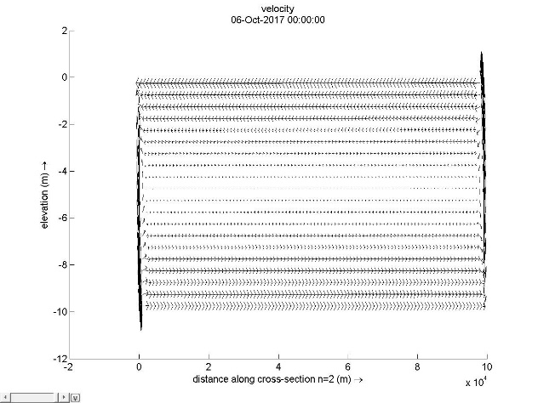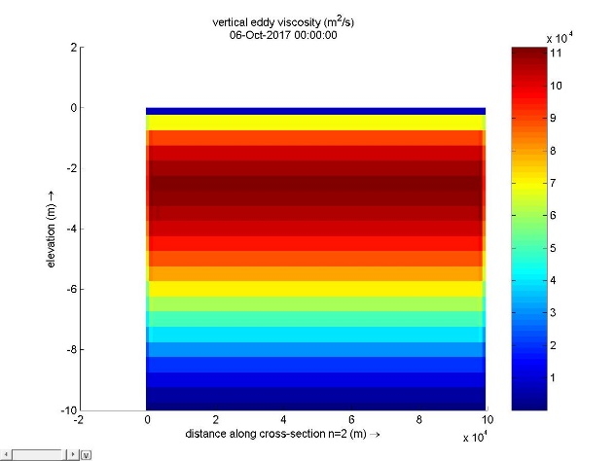

(c) (d)

Fig.6 (a) water depth with time (b) water level with distance (c) velocity (d) viscosity

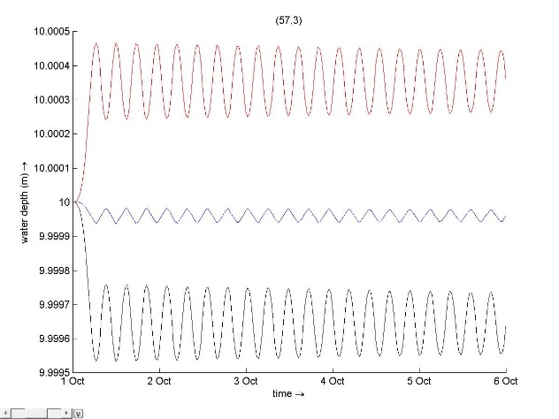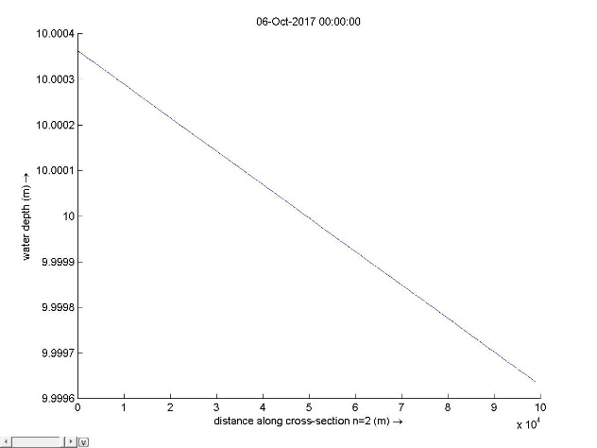

1. (b)

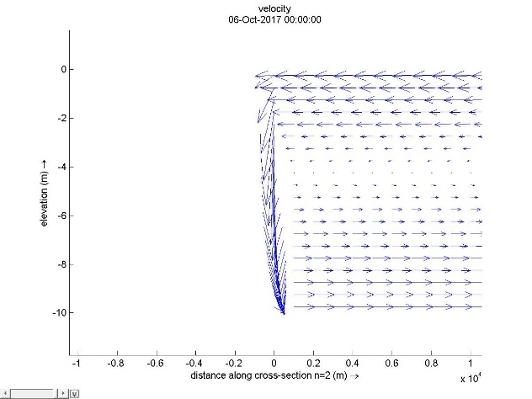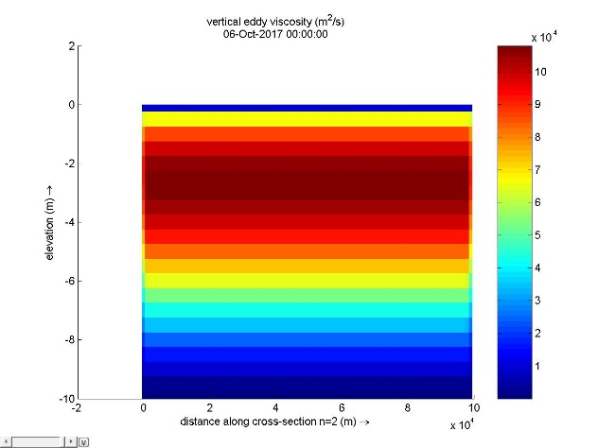

(c) (d)

Fig.7 (a) water depth with time (b) water level with distance (c) velocity (d) viscosity

For this one equation model, strictly it mixes faster than K-epsilon model.

1. Performance of constant model

Tab.3 setup 3

|  |  |  |  |  |  |
| --- | --- | --- | --- | --- | --- |
|  | Bathymetry | Grid | Windspeed | 3d model | Viscosity |
| Fig.8 | Uniform | No extend | 0-1-1 | Constant | 1e-6 |
| Fig.9 | Uniform | No extend | 0-1-1 | constant | 1e-3 |

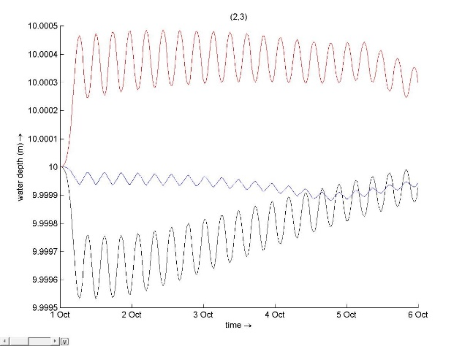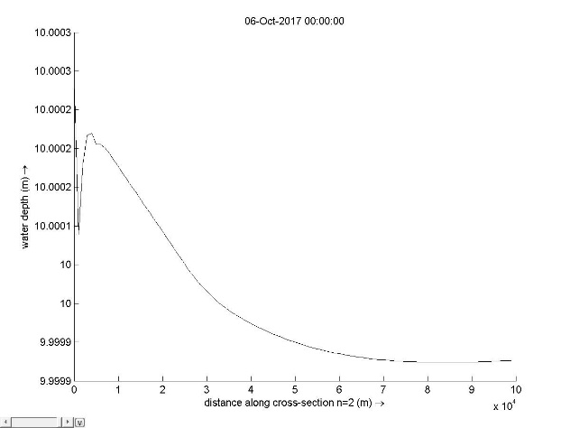

1. (b)

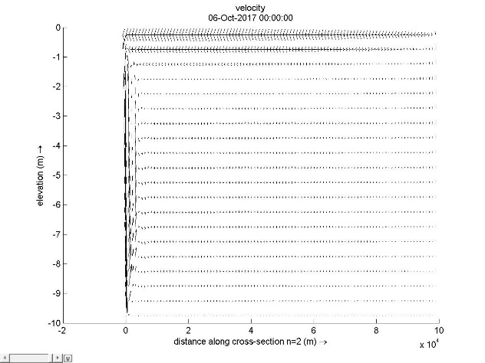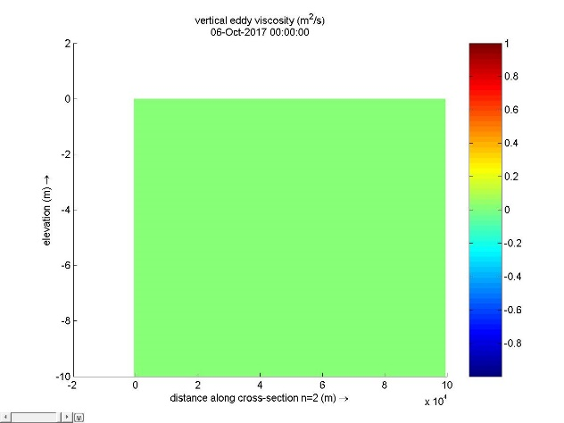

(c) (d)

Fig. 8 (a) water depth with time (b) water level with distance (c) velocity (d) viscosity

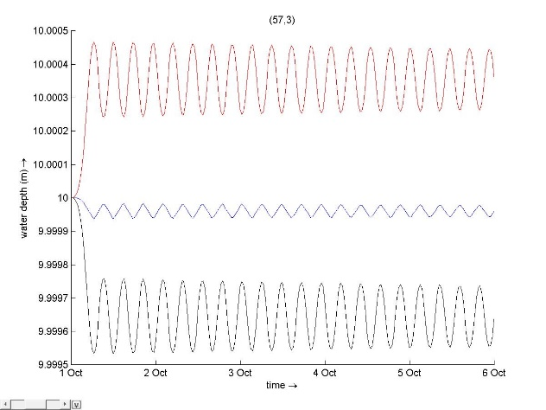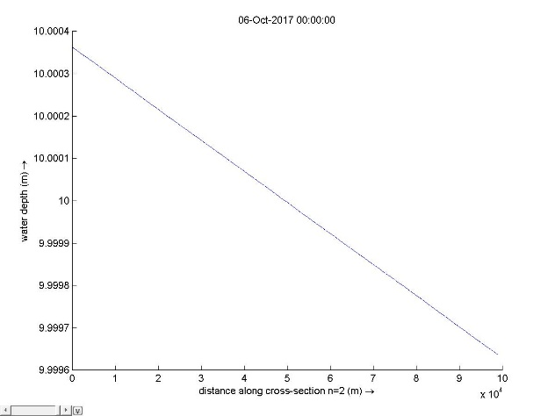

1. (b)

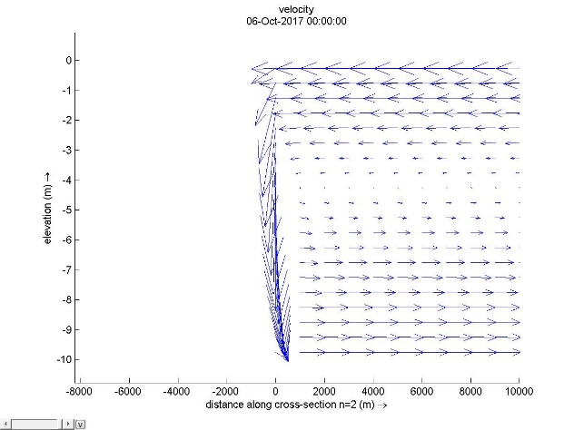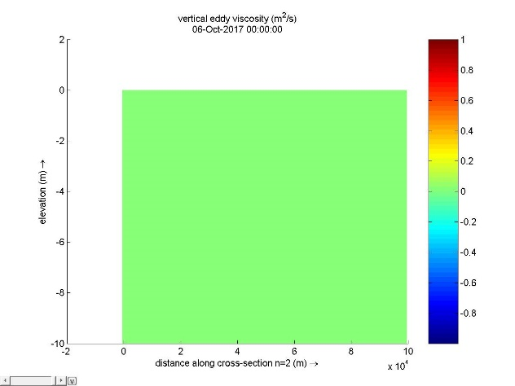

(c) (d)

Fig.9 (a) water depth with time (b) water level with distance (c) velocity (d) viscosity

As we see in constant model, we can not get a full solution of this problem. There is no return flow in this process. A constant eddy viscosity leads to parabolic vertical velocity profiles. That means every thing has been destroyed in this case.

1. Performance of Algebraic model

Tab.4 setup4

|  |  |  |  |  |  |
| --- | --- | --- | --- | --- | --- |
|  | Bathymetry | Grid | Windspeed | 3d model | Viscosity |
| Fig.10 | Uniform | No extend | 0-1-1 | Algebraic | 1e-6 |
| Fig.11 | Uniform | No extend | 0-1-1 | Algebraic | 1e-3 |

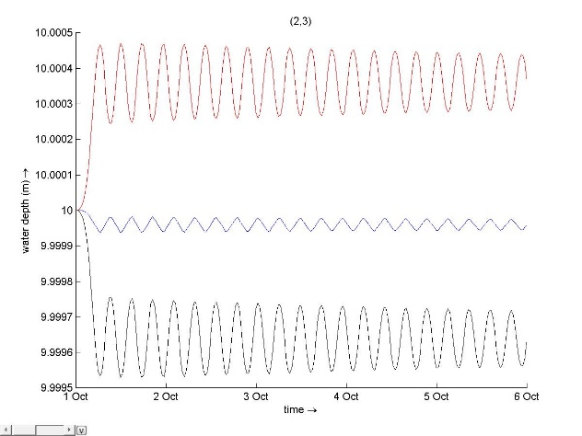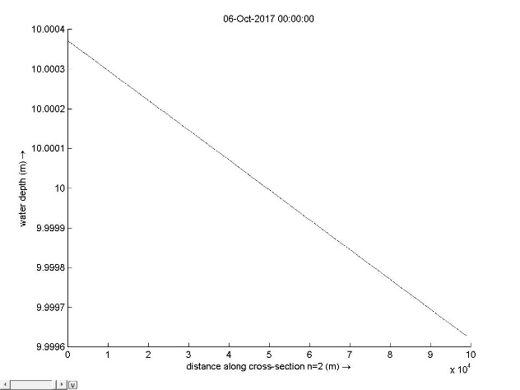

1. (b)

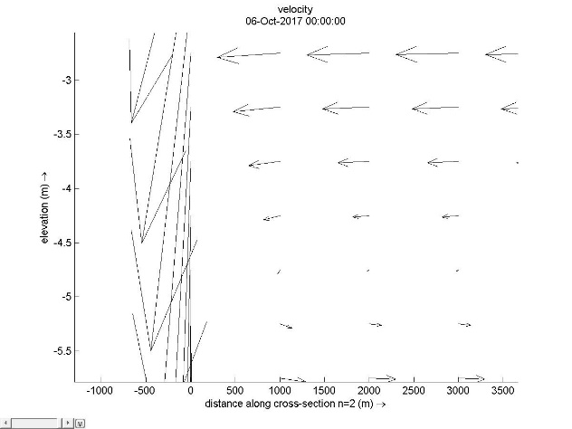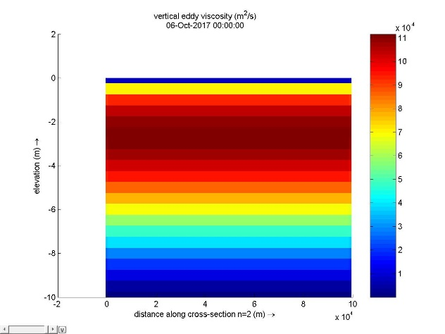

(c) (d)

Fig.10 (a) water depth with time (b) water level with distance (c) velocity (d) viscosity

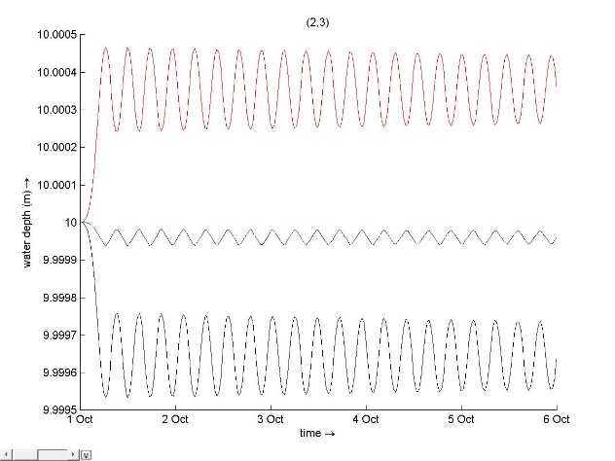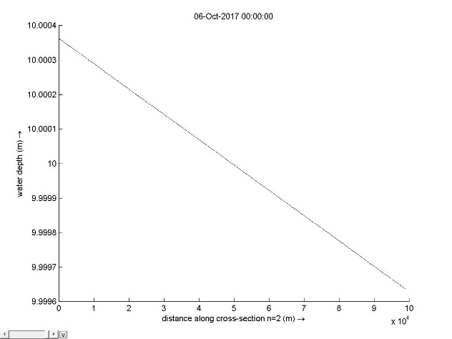

1. (b)

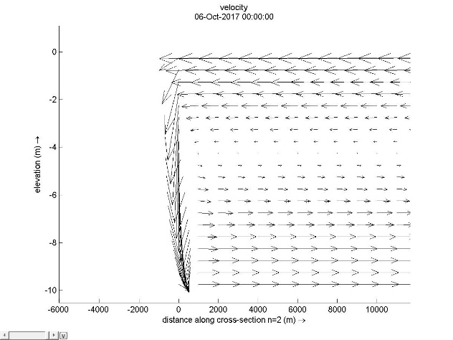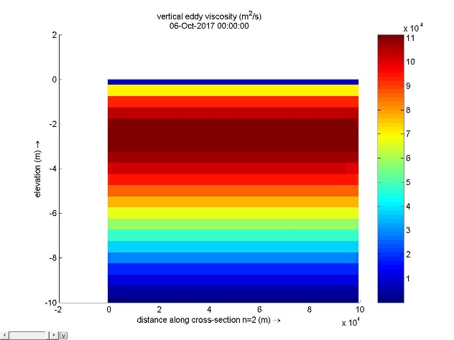

(c) (d)

Fig.11 (a) water depth with time (b) water level with distance (c) velocity (d) viscosity

This 0 equation mixes faster than K-Epsilon model as well. Comparing to constant model, this model is acceptable because this is steady-state solution and in horizontal direction, forcing wind causes velocity gradient whereas in the middle of one layer gradient is 0. This is where thermocline exist. In vertical direction, still have issue about artificial diffusion.

Finally, we consider K-Epsilon model as the best solution because it solves two equation at one time and relatively reasonable in the process of transport.

The essential difference between averaged depth simulation and 3D simulation is due to scale. In reality, surge and particles transport in three dimensions while we simplify it by averaging or even compress to 2 or 1 dimension. In the mean time, once scale it for simplicity, we got to pay for that and hence one way is to consider the order of diffusion parameter. Lower the dimension, higher order the diffusion parameter. For particle transportation problem, using 3D model can simulate its diffusivity process better because it has random motion in reality and we are concerned about all dimensions. While simulating surges, we only focus on its trajectory in one dimension. so shallow water assumption and water depth averaged simulation is sufficient to trace whole process in open channel flow.

**Further discussion**

What is the influence of the background viscosity on the spin‐up time and the final stationary results?

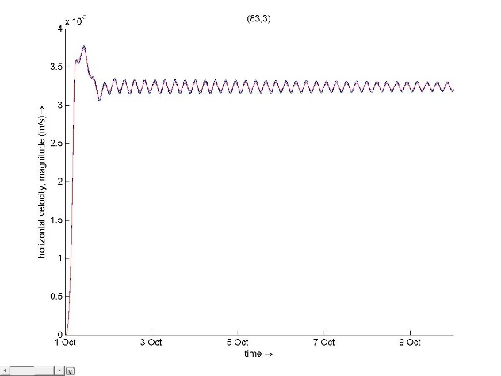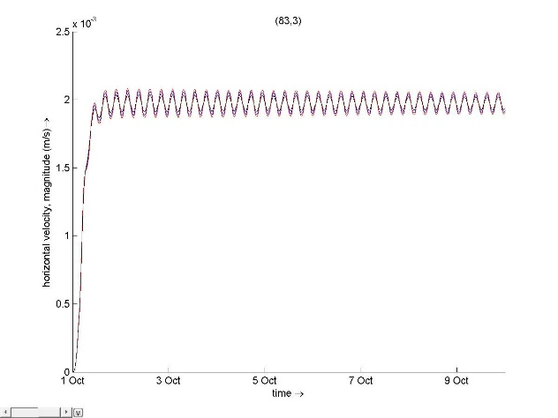

1. (b)

Fig.12 horizontal velocity (a) viscosity 1e-6 (b) viscosity 1e-3

Only varying vertical viscosity from 1e-6 to 1e-3, higher viscosity causes higher diffusivity and hence shorter the spin-up time.

For final stationary result, magnitude of horizontal velocity becomes smaller with larger viscosity. That is due to more turbulence introduced by flow and more energy is dissipated.

**How can you affect the spin‐up time by specifying a gradually increasing wind, rather than a stepwise increasing wind?**

(change wind speed to “block” and the same plot as before to see difference)

Tab.5 setup 5

|  |  |  |  |  |
| --- | --- | --- | --- | --- |
| Time frame | Speed | Degree | Type | fig |
| 01 10 2017 00 00 00 | 0 | 90 | Gradually increasing wind speed | Fig.13(a) |
| 01 10 2017 12 00 00 | 0.5 | 90 |
| 02 10 2017 00 00 00 | 1 | 90 |
| 10 10 2017 18 00 00 | 1 | 90 |
| 01 10 2017 00 00 00 | 0 | 90 | Stepwise increasing wind speed | Fig.13(b) |
| 01 10 2017 12 00 00 | 0.5 | 90 |
| 02 10 2017 00 00 00 | 1 | 90 |
| 10 10 2017 18 00 00 | 1 | 90 |

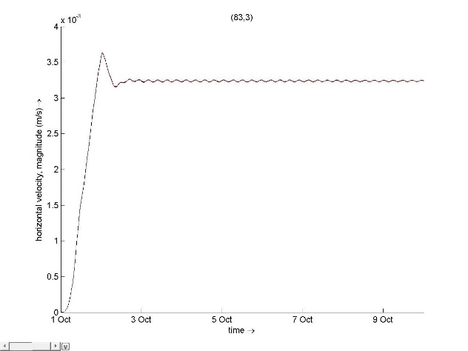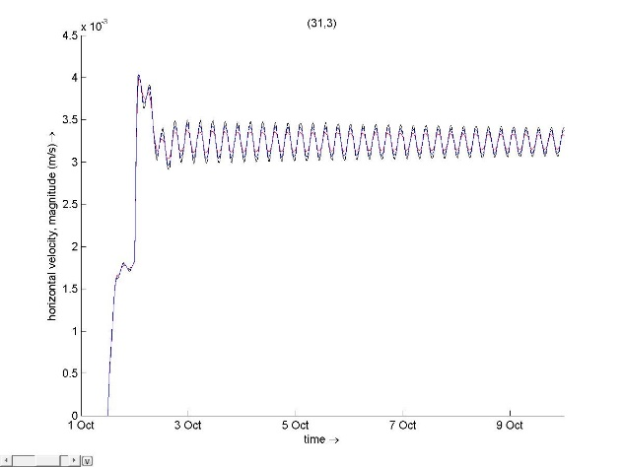

1. (b)

Fig.13 horizontal velocity of different wind forcing

For spin-up time, we can see gradually increasing wind speed is around 2 and half days while for stepwise, it is 3 days or more. We notice that horizontal velocity changes with different force types. It rises linearly as forcing wind is linearly increasing and stepwise as forcing wind correspondingly. Basically when disturbance occurs suddenly, it requires more time to be stable than gradually change flow pattern.

**Part 2 wind imposed on closed basin with density changes**

In this model, we assess closed basin imposed by weaken wind and salinity mixing.

Tab.6 setup 6

|  |  |  |  |
| --- | --- | --- | --- |
|  | Vertical eddy viscosity | Vertical diffusivity | Ozmidov Length |
| Fig.14 | 1e-3 | 1e-5 | 0.2 |
| Fig.15 | 1e-3 | 1e-5 | 0.1 |
| Fig.16 | 1e-3 | 1e-5 | 0.05 |

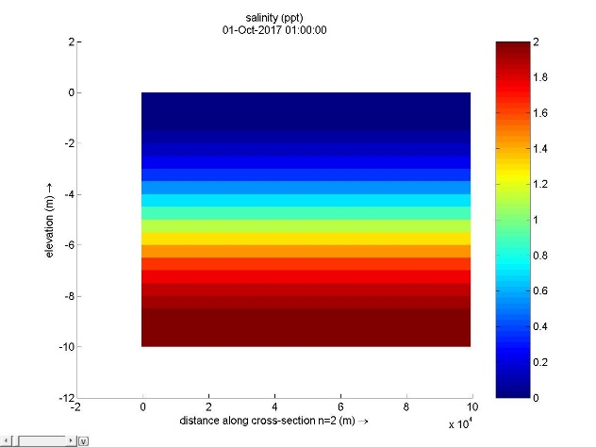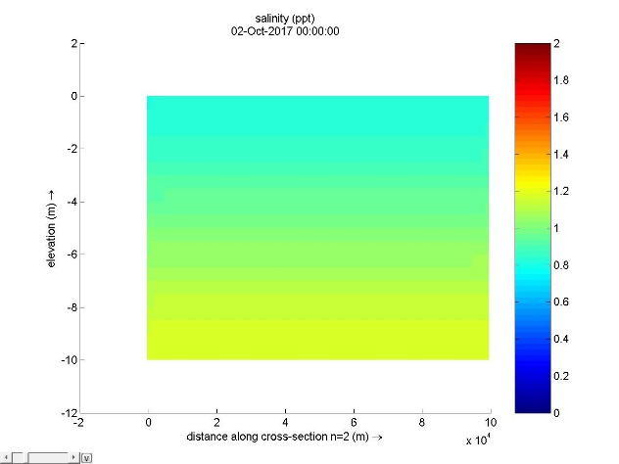

1. first time step (b) second day

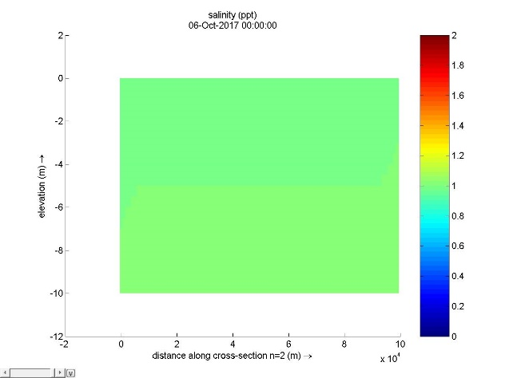

(c) final time step

Fig.14 setup1

From fig.14 (a) at first time step, the mixing process seems fast and have already mixed before the second day. Energy dissipation is due to length scale and viscosity. With small length scale, viscosity dominates which is defined in Delft3D as below,

Transport equation,

Mixing time,

Because slower mixing process is expected in this case, hence we change length scale to a lower value.

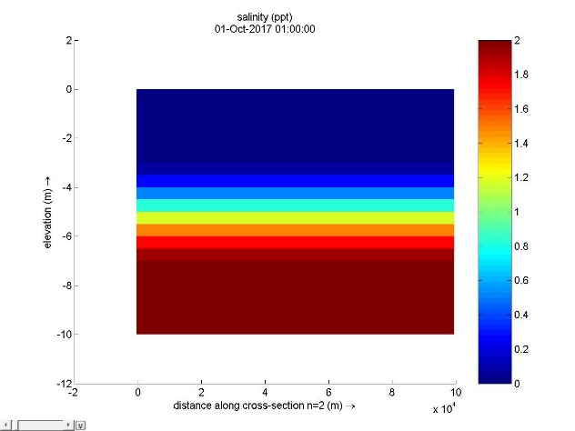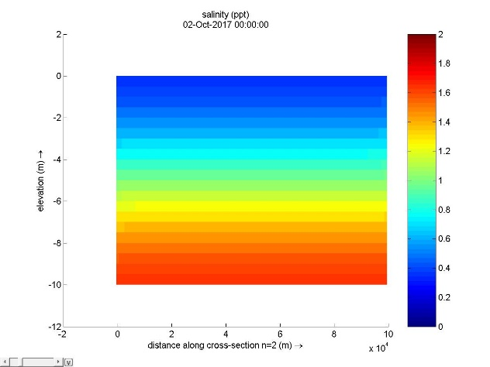

(a)first time step (b)second day

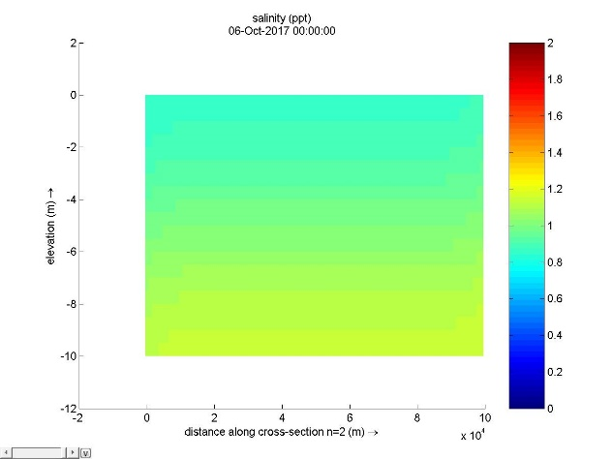

(c)final time step

Fig.15 setup2

Obviously, this mixing process is much slower than base case while still higher than our expectation. We further reduce Ozmidov length scale to get a more stable result.

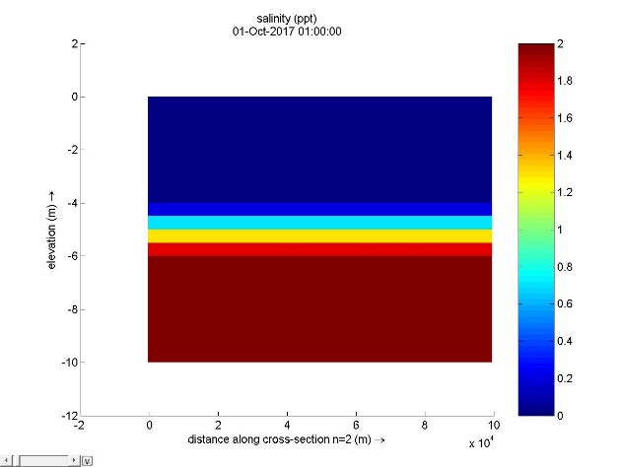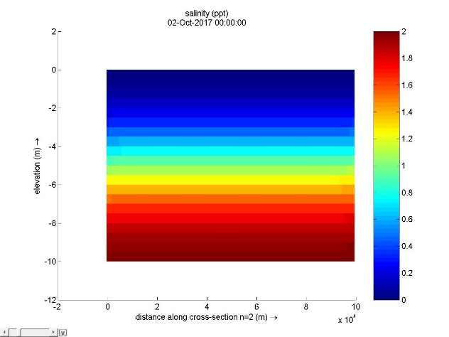

(a)first time step (b)second day

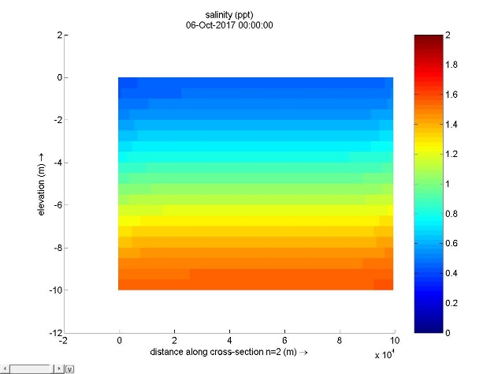

(c)final time step

Fig.16 setup 3

At final time step, the flow is still mixing. Basically, reducing Ozmidov Length scale dominates in transport process. To understand this, we set Ozmidov Length scale to 0 and see difference.

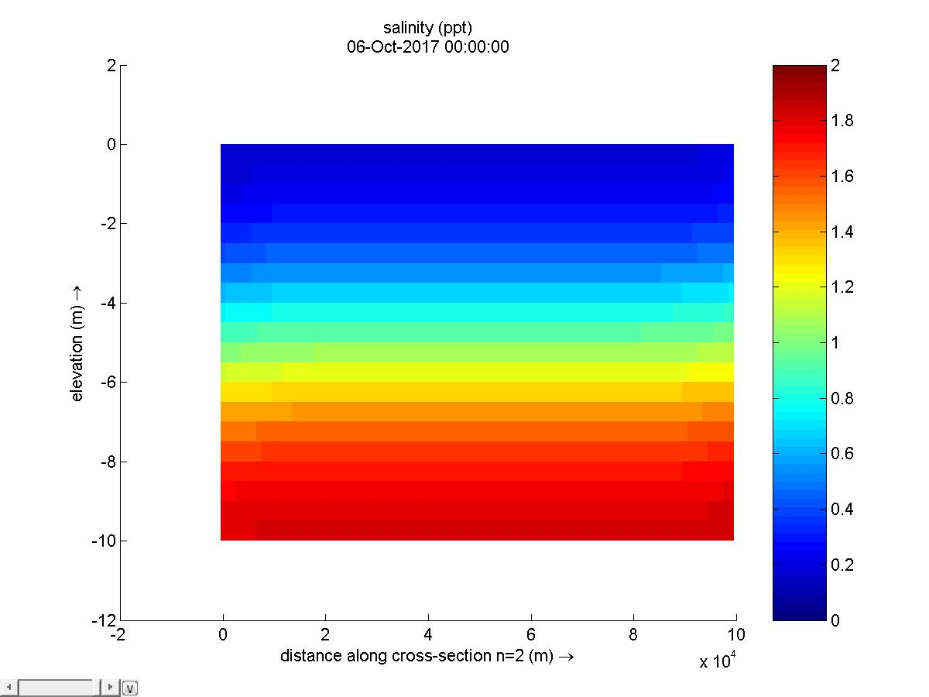

Fig.17 Ozmidov length scale 0 at final time step

In this case, mixing process continues instead of remaining stagnant. Hence, this is because diffusivity parameter dominates.

In order to test which one dominates, we set eddy viscosity and diffusivity to lower value based on length scale 0.05.

Tab.

|  |  |  |  |
| --- | --- | --- | --- |
|  | Vertical eddy viscosity | Vertical diffusivity | Ozmidov Length |
| Fig.17 | 1e-6 | 1e-4 | 0.05 |
| Fig.18 | 1e-8 | 1e-5 | 0.05 |

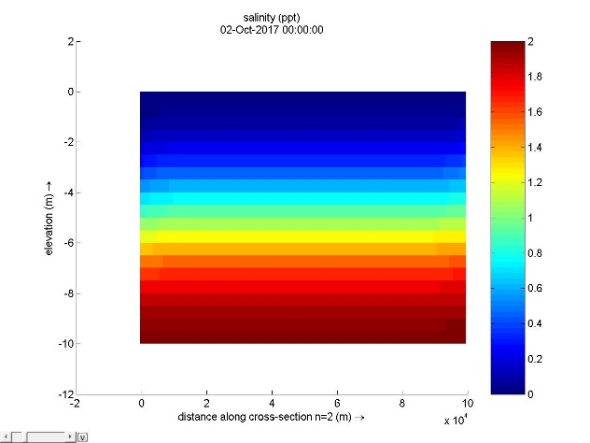

(a)first time step (b)second day

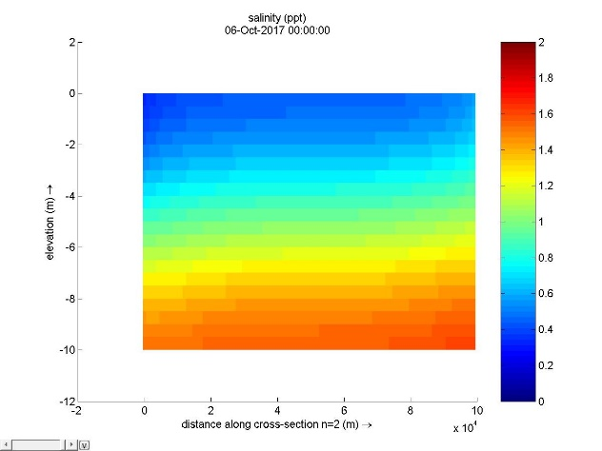

(c)final time step

Fig.17

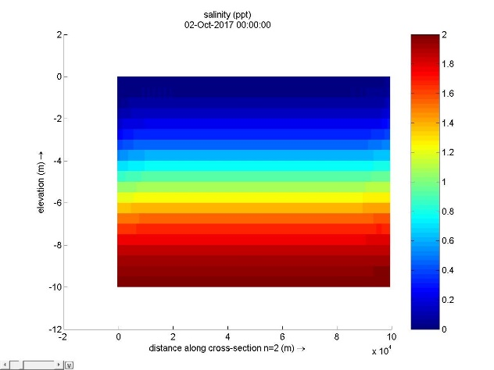

(a)first time step (b)second day

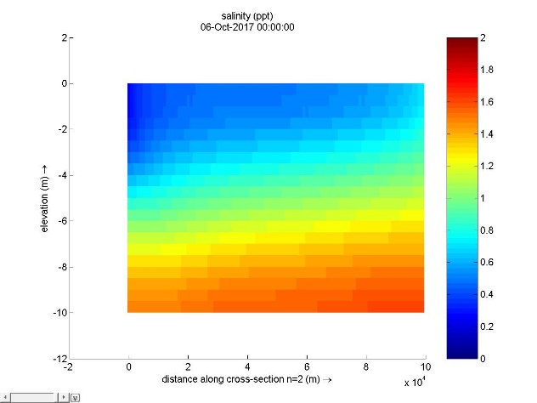

(c)final time step

Fig.18

Actually, no difference between these smaller value proves Ozmidov length scale dominates in a way.

Theoretically turning on vertical filter will help to remove computational oscillations and slow down undesirable mixing.

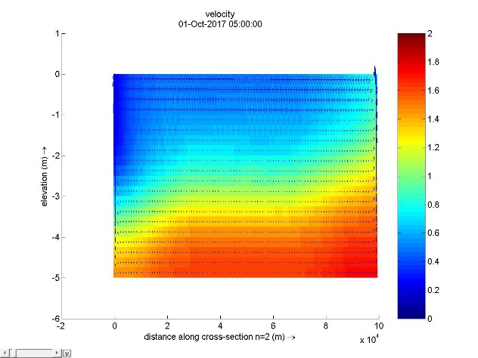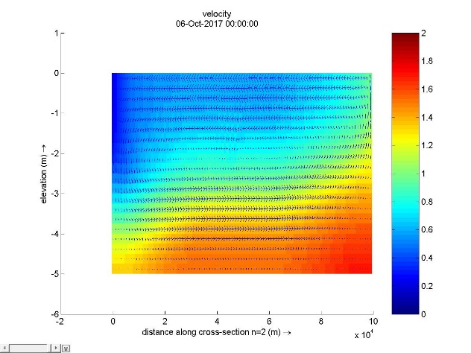

1. no vertical filter (b) with vertical filter

fig.19 test for vertical filter

sigma coordinate system is quite useful to reduce artificial diffusion and artificial flow due to truncation error.

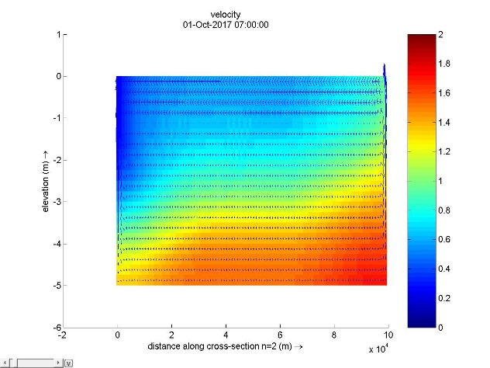

1. without sigma (b) with sigma

fig.20 test for sigma coordinate

In order to get more stable solution, we change bathymetry to deeper value so that wind only affects the upper region and obviously we notice two kinds of flow pattern which indicates that circulation occurs in the upper layer and one direction flow in the lower layer.

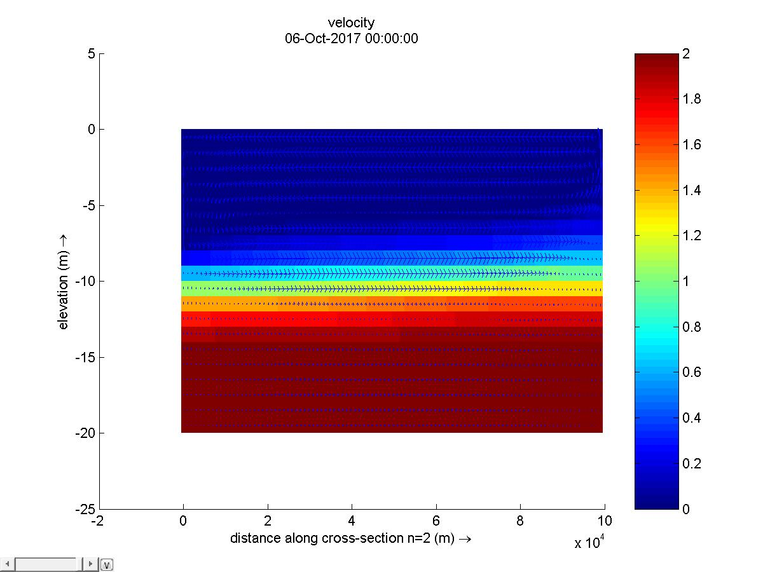

Fig.21 end product